E-CONTENT

MJMC, SEM-IV, PAPER-XIII (CC- 401)
Topic : Structure of a Typical Small Magazine

Date : 25-01-2020, TIME : 1.00 P.M.-2.00 P.M.

PREPARED BY : AMIT KUMAR

Structure of a Typical Small Magazine

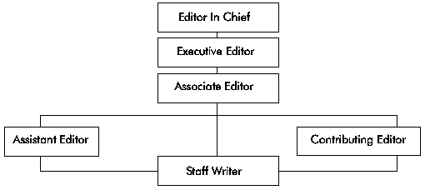
Structure of a Typical Small Magazine
The staff writer is the immediate target-partner because she/he combines the function of a reporter with that of a feature writer. This means that she/he can break the news about a vaccine trial by providing hard, objective facts and also write subjective accounts of the significance of the vaccine trial based on his/her understanding of the issues and the interpretation she/he gives to them. Cultivate him/her through personalized correspondence, invitations to guided tours, routine media briefings and media breakfasts/dinners. Target editors and others above the level of staff writers through special guided tours/video screenings and media breakfasts/dinners.

